Sesame Beef Stir Fry

Ingredients

USMETRIC

1X2X3X

BEEF MARINADE
- ▢ 6 g garlic minced
- ▢ 10 g fresh ginger grated
- ▢ 45 g reduced sodium soy sauce
- ▢ 20 ml rice vinegar
- ▢ 20 ml sesame oil
- ▢ 20 ml sesame seeds
- ▢ 1 g Chinese 5 spice
- ▢ 1 g black pepper

STIR FRY
- ▢ 450 g flank steak thinly sliced
- ▢ 100 g snow peas sliced in half across
- ▢ 70 g carrots sliced
- ▢ 8 green onions sliced
- ▢ 65 ml beef broth
- ▢ 40 ml reduced sodium soy sauce
- ▢ 20 ml honey or light brown sugar
- ▢ 20 ml rice vinegar
- ▢ 5 g garlic minced
- ▢ 10 ml sesame oil
- ▢ 2 g fresh ginger grated
- ▢ 2 g cornstarch
- ▢ 1 g red pepper flakes
- ▢ 40 ml vegetable oil for cooking

Instructions
- Combine marinade ingredients in bowl and add flank steak. Set aside 15 minutes.
- Heat 1 Tbsp vegetable oil in large skillet over MED HIGH heat. Remove excess marinade from steak and cook in a single layer, for 2-3 minutes, stirring to cook both sides. Depending on the size of your pan, you may need to do this in batches. Remove steak to plate.
- Heat remaining 1 Tbsp vegetable oil, then add peas, carrots and green onion and cook stirring often, 2-3 minutes.
- Whisk together broth, soy sauce, honey/brown sugar, rice vinegar, garlic, sesame oil, fresh ginger, cornstarch, and red pepper flakes. Add steak and sauce to skillet, stirring to combine. Sauce will thicken.
- Stir in cooked ramen noodles if using, and serve!
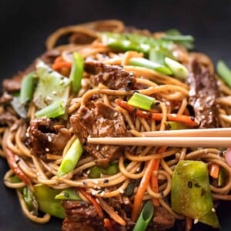

https://cafedelites.com/sesame-beef-stir-fry/

Mushroom Coconut Beef Stroganoff

INGREDIENTS
- 1 (13.6 ounce) can full fat coconut milk
- 1 lemon, juiced
- 2 tablespoons avocado oil
- 1/2 pound steak, cut into thin strips (such as flank, vacio, sirloin, tenderloin, top sirloin)
- 1 tablespoon ghee
- 3 3/4 cups baby bella mushrooms, thinly sliced
- 1 medium shallot, thinly sliced
- 3 cloves garlic, thinly sliced
- 1/2 cup chicken stock
- 2 tablespoons dill, finely chopped, plus more for garnish
- 1 tablespoon Dijon mustard, (or grainy)
- Kosher salt and freshly cracked black pepper

METHOD

TO MAKE THE COCONUT SOUR CREAM
- STEP 1
The day before cooking, place an unshaken and sealed can of full-fat coconut milk in the fridge. The following day, open the can and spoon off the solidified cream. Add cream to a bowl along with the juice of one lemon. Whisk until smooth and creamy. Taste for seasoning and adjust lemon juice as required. Cover bowl with wrap and return coconut to fridge until ready to serve.

TO MAKE THE BEEF STROGANOFF
- STEP 1
Preheat a 12” stainless-steel or cast-iron skillet over high heat. Add avocado oil and let heat 30 seconds. Add steak and cook undisturbed 2-3 minutes. Flip steak slices and cook an additional 1 minute. Transfer browned steak to a bowl and set aside.
- STEP 2
Return pan to stovetop and lower heat to medium. Add ghee and mushrooms and season with a pinch of salt. Sauté mushrooms 4-5 minutes and scrape any brown bits on the bottom of the pan.
- STEP 3
Once mushrooms have browned and their moisture has evaporated, add shallots and garlic. Sauté an additional 2-3 minutes. Add chicken stock to deglaze pan. Cook an additional 30 seconds or until stock has reduced by ¼.
- STEP 4
Add 1 cup coconut ‘sour cream’, mustard and a pinch of black pepper, stir to combine. Gently simmer the sauce for 2-3 minutes. Taste for seasoning and adjust salt and pepper as required.
- STEP 5
Return beef to pan and toss to coat. Remove from heat, add dill and toss everything to combine.
- STEP 6
Serve overtop of mashed potatoes and garnish with more fresh dill.

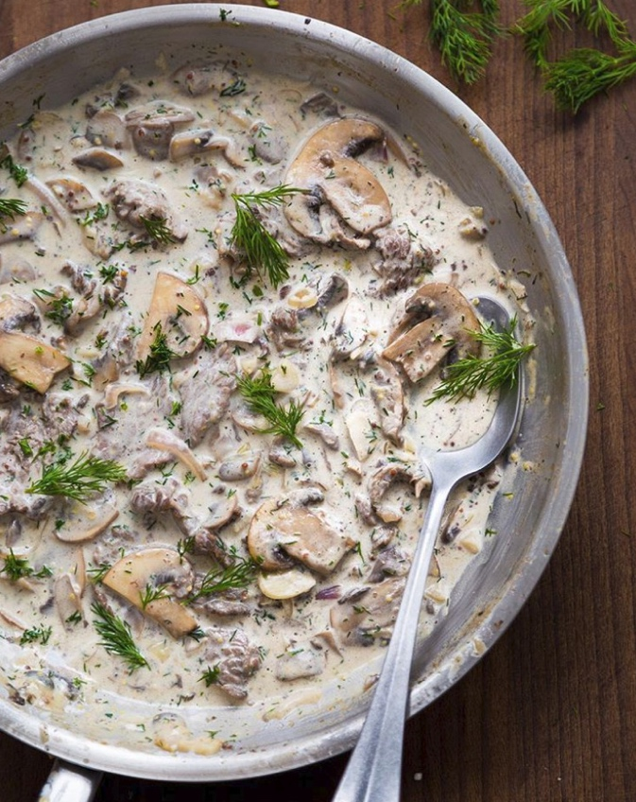
https://thefeedfeed.com/primal_gourmet/mushroom-coconut-beef-stroganoff

Butter Chicken
Ingredients
For the chicken / marinade
-1 tbs fresh ginger (minced or paste)
-1 tbs fresh garlic (minced or paste)
-500 g chicken thigh, sliced
-1/2 c full fat yogurt
-1 tsp turmeric powder
-1 tsp Kashmiri chili powder
-1 tsp cumin
-1tsp coriander
-1.5 tsp garam masala
-1 or 2 tbs lemon juice
-2 tsp salt
For the butter chicken sauce:
-1 tbs neutral oil
-2 tbs ghee
-1 Cinnamon stick
-1 star anise
-1 tbs cumin seeds
-1 small red onion, finely diced
-5 medium fresh tomatoes, quartered (can also use canned tomatoes)
-1 tbs ginger and garlic (paste or minced)
-1.5 tsp kashmiri chili powder
-1 tsp cumin
-1tsp coriander
-1/3 cup heavy cream
-Salt to taste
-1 or 2 tbs of fenugreek leaves
-Fresh cilantro, chopped (optional garnish)
For the Paratha:
-500 g atta flour (whole wheat), or AP flour
-10 g salt
-30 g oil or ghee
-300 g room temperature water
-more flour for kneading/rolling
For the Jeera Rice
-1 cup basmati rice
-2 tbs ghee
-2 tsp cumin seeds
-1 or 2 bay leaves
-1 star anise
-1 cinnamon stick
-2 or 3 cardamom pods
-1 small green chili, finely diced
-pinch of salt
-2 cup water
https://www.instagram.com/reel/DCnBDu8yzV_/ anasofiafehn

Honey Mustard Salmon In Foil

Ingredients

USMETRIC

1X2X3X
- ▢ 80 ml honey
- ▢ 60 g butter
- ▢ 60 ml whole grain mustard
- ▢ 40 g Dijon mustard smooth and mild
- ▢ 5 cloves garlic peeled and minced
- ▢ 40 ml lemon juice freshly squeezed
- ▢ 1 g chili powder or cayenne powder, optional – adjust to your tastes and spice preference
- ▢ 2 1/2 pund side of salmon
- ▢ 1 pinch salt to season
- ▢ 1 pinch cracked pepper to taste
- ▢ 8 g fresh parsley chopped
- ▢ 4-5 lemon wedges optional

Instructions
- Position a rack in the middle of the oven. Preheat oven to 375°F | 190°C. Line a baking tray / sheet with a large piece of foil, big enough to fold over and seal to create a packet (or 2 long pieces of foil over lapping each other lengthways to create your salmon packet, depending on the width of you fillet).
- In a small saucepan, combine the honey, mustards, butter, garlic and lemon. Whisk until the honey has melted through the butter and the mixture is well combined.
- Place the salmon onto lined baking tray | sheet. Pour the butter/honey mixture over the salmon, and using a pastry brush or spoon, spread evenly over the salmon. Sprinkle with a good amount of salt (about 2 teaspoons) and cracked pepper. Fold the sides of the foil over the salmon to cover and completely seal the packet closed so the butter does not leak.
- Bake until cooked through (about 10-12 minutes, depending on the thickness of your fish and your preference of doneness). Open the foil, being careful of any escaping steam, and grill / broil under the grill / broiler for 3-4 minutes on medium heat to caramelise the top. Garnish with parsley and serve immediately with lemon wedges.
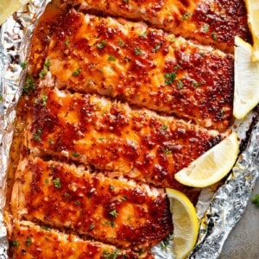

https://cafedelites.com/garlic-butter-honey-mustard-salmon-in-foil/

CRANBERRY WALNUT BREAD

INGREDIENTS
- 1 ½ cups warm water (105 to 115ºF)
- 1 tablespoon active dry yeast
- about 6 cups all-purpose flour, divided
- ½ cup honey
- ¼ cup olive oil
- 1 ½ teaspoons salt
- 1 teaspoon ground cinnamon
- ¾ to 1 cup dried cranberries
- ¾ to 1 cup chopped raw walnuts

INSTRUCTIONS
- To the bowl of a stand mixer fitted with the paddle attachment,* add the warm water then sprinkle in the yeast. Next, add in ½ cup of the flour and mix briefly on low speed to combine. Let the mixture sit for 10 minutes to proof the yeast.
- Add in the honey, olive oil, salt and cinnamon and mix briefly again on low to combine.
- With the mixer on low speed, slowly add in the remaining 5 ½ cups of the flour, about 1 cup at a time (SEE NOTES**). Once the dough forms a shaggy mass, stop the mixer and switch to the dough hook.
- Knead on low speed for about 3 to 5 minutes, until the dough is smooth and elastic (if the dough is too sticky, slowly add in additional flour until it reaches the desired consistency).
- Shape the dough into a ball and place in a large lightly oiled bowl. Turn once to coat, then cover with plastic wrap or a clean kitchen towel. Allow the dough to rise until it has doubled in bulk, about 1 ½ to 2 hours.
- Line a large baking sheet with parchment paper, then sprinkle lightly with cornmeal. Set aside.
- Gently deflate the dough and transfer to a lightly floured surface. Knead in the cranberries and walnuts by hand.
- Split the dough into two equal sized pieces and form each into a ball about 5 to 6 inches in diameter. Place both on the prepared baking sheet, then cover with a damp towel(s) and let rise again for another 30 to 45 minutes, until puffy.
- Meanwhile, preheat the oven to 350ºF. Once the loaves have proofed, sprinkle the tops lightly with flour, then use a serrated knife to cut a cross into the top of each loaf (about 1-inch deep).
- Bake for about 35 to 45 minutes, until golden brown and the loaves sound hollow when tapped on the bottom (if you have an instant-read thermometer, the internal temperature should be about 190ºF). Transfer the loaves to a wire rack to cool before slicing!

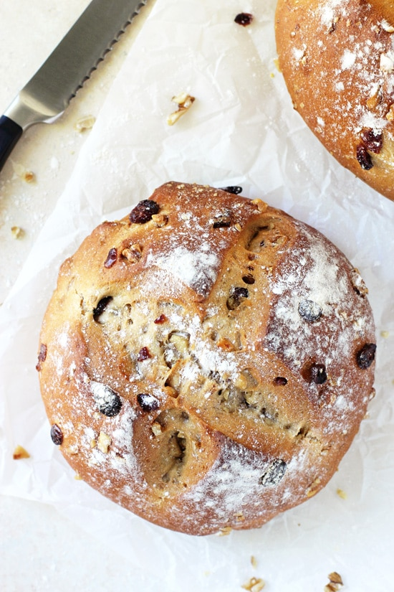
https://cooknourishbliss.com/2012/11/14/cranberry-walnut-bread/

